Study Visit Report
RISE ERASMUS+ Project
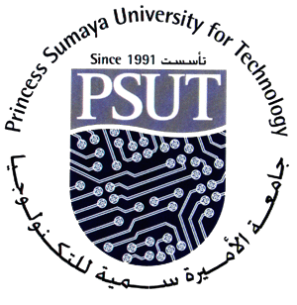
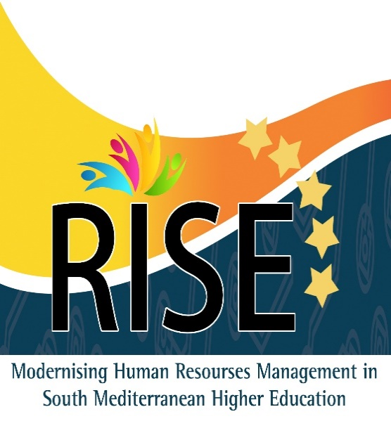

To: Prof. Walid Salameh / RISE Project Coordinator
Princess Sumaya University for Technology
From: Dr Mahmoud Owaydah and Reem Albasha / Princess Symaya University for Technology.
Date: [ 30 / 5 / 2016]
Venue: Rouen University, France
Subject: Study Visit Report (Rouen University, Rouen, France, 9th – 14th May, 2016)

Summary:
There is a worldwide consensus today on the relevance of quality human resource management (HRM) for the optimization of Higher Education Institutions’ performance. HEIs are facing increasingly complex contexts, which require HRM models able to respond to new challenges in the selection, development and motivation of their staff. HR approaches focused on staff recruitment, organization of employment contracts and salary payment are completely superseded by the necessity to take account of new issues, such as training, promotion and encouragement, development support and strategic planning for future needs.
In South Mediterranean countries, aspects such as the socio-political climate and the level of state expenditure in education influence the capacity of HEIs to address these challenges, calling for supporting actions in this regard. Against this background, RISE’s main goal is to contribute to South Mediterranean HE Reform Agenda through the modernization of People Management. This global purpose will be targeted by means of three specific objectives:
* To build up capacities and skills in HRM on target South Mediterranean HEIs for stronger organizational efficiency;
* To create a regional network on HRM as a forum for exchange of good practices; * To conceive and develop institutional HR strategies in South Mediterranean HEIs.
These objectives will be pursued by a set of interrelated and focused activities, starting with an in-depth analysis of the target HEIs’ HR practices and needs to shape the rest of interventions. A range of skills enhancement actions will follow, including tailor-made training (on-site/online), upgrading of HR technical tools, and drafting and publication of a Guide on Good Practices on HRM. Targeted dissemination and sustainability actions will optimize exploitation of results, helping the consortium multiply and extend the benefits of the outputs generated to other HEIs in the region.
This study visit achieved its objectives and goals by attending a series of lectures, discussions, and open sessions about the Rouen University HR. During this visit, we exchange the ideas, good practices and cooperation opportunities within South Mediterranean universities and Rouen University.
Points:
Tuesday 10th May
- The vice president of Rouen University (UPIN) started the event by a welcoming speech. She talked about achievements of Rouen University regarding HRM, and she presented some statistics about HR at the university.
- Professor Walid Salameh, the project coordinator, talked about RISE project in general, pointing out the main objectives of the project. Hoping that this project will help in raising the HR staff skills necessary for their work in the Higher Education Institutions, creating a regional network on HRM between the partners, and conceiving and developing an effective HR strategies.

- Presentations
The partners presented their presentations according to the templet sent by Rouen University. The main topics in this template are:
- An overview of the university.
- The organization chart of HR department.
- HR strategy.
- Staff recruitment.
- HRM tools.
- Staff training.
- Working conditions.
The Presentations Was as Follows:

- Continuing Training University, Algeria.
- A higher education and training institution.
- Total number of students is 47924.
- Total number of staff is 2179 (96 Professor, 1006 Permanents, 1077 Contracts).
- There is 19 HRD with 159 employee distributed on 53 center.
- They use software only for wages called GENISOFT.
- They are controlled by: Financial Controller, Public Function Department.
- The HR policy is stated in the Annual Management Plan of HR. One of the adopted policies is the Staff nominating at 31 December of each year.
- The target audience of training plan is the administrative staff with budget 2000000 DA.
- Since the University is a public institution, it is governed by the the Public Service Regulations.

- The University of Laghouat, Algeria,
- A public institution with a professional, scientific and cultural character, under the supervision of the Ministry of Higher Education and Scientific Research.
- Total number of students is 27434.
- Total number of staff is 1967 (946 academics, 1021 non-academic).
- 35 is the number of HR department staff.
- The do not use special software for HR, instead they use only windows and Microsoft Office.
- At the HR Department there are two parts: one for the academic staff, the other for non-academic staff.
- They are controlled by: Financial Controller, Public Function Department.
- HR Policy is stated in the Human Resource Management Planning (HRMP) for each financial year.
- HR Department identify the needs and the requirements for both the teaching and non- teaching staff.
- They use both External and Internal training courses for both teaching and administrative staff.

- Ministry of Higher Education & Scientific Research, Jordan.
- A governmental institution.
- It has 250 employees.
- The number of HR Department is 10 employees.
- They use HRMIS, E-Card as software.
- The organizational chart of "HR & Institutional Development Department" consists of three sections; HR Management Section, HR Development Section and Institutional Performance Development Section.
- Since The MOHE is a public institution, it coordinates with the Civil Service Bureau (CSB) regarding staff recruitments.
- Training is restricted to those who are classified on the job hierarchy of the ministry.

- Princess Sumaya University for Technology (PSUT), Jordan
- A private, non-profit university.
- Total number of students is 3000.
- Total number of staff is 303 (121 academics, 182 non-academic).
- No HR Department. instead there is a Personal Section (3 employees) within Administrative Affairs Department.
- The Personal Section use ORACLE 9i as a specific software.
- The University President, Deans of Council and the Employee Affairs Committee are the relative bodies for HR decisions.
- There are documents formalize HR Policy such as: Employees Bylaw, Employees Regulations, Jordanian Labor law, Jordan Universities’ law, Jordanian Social Security Low.
- The council of the Deans is responsible for teaching staff recruitments; while the Employee Affairs Committee is responsible for administrative staff recruitments.
- There is no training plan, but the University is planning to have one (for administrative staff).

- Mutah University, Jordan.
- A Public University.
- Total number of students is 19660.
- Total number of staff is 3050 (550 academics, 2500 non-academic).
- Number of HR Department staff is 24.
- HR department consists of four sections:
- Faculty staff members Affaires .
- Archive "files and records " .
- Human resources' services .
- Social Security .
- The relevant bodies for HR Policy are: Deans Council, Dean of Business Administration Collage, Member of Managers' Selection Committee.
- The University has a continuous training plan for all of employees.

- Tafila Technical University (TTU), Jordan.
- A Public University.
- Total number of students is 5105.
- Total number of staff is 913 (244 academics, 687 non-academic).
- Total number of HR staff department is 13.
- HR Department uses home developed information system based on Oracle 11G as a software.
- HR Department consists of four sections; Administrative Staff Section, Academic Staff Section, Health Insurance Section, Social Security Section.
- The Internal Audit Department and Jordan Audit Bureau are relevant bodies for HR decisions.
- Government Cabinet and by-laws issued by TTU Councils are formalize HR policy.
- Each college and department determines its needs for teaching and non-teaching staff.
- Training is given only in university campus, and main topics are languages, management skills, computer skills.

- CADI AYYAD University, Morocco
- A Public University.
- Total number of students is 75000.
- Total number of staff is 1460 (864 administrative).
- HR Department contain three sections, one responsible for the services, the second responsible for the academic staff and the third section responsible for the administrative staff.

- Sultan Moulay Slimane University, Morocco.
- A Public University.
- Total number of students is 23500.
- Total number of HR department staff is 20
- Software ERP openerp is used.
- The relevant bodies of HR decisions are:
- The Ministry,
- University Consulting,
- Management Consulting.
- The relevant documents formalize HR Policy are:
- Project development of the ministry of guardianship,
- Project development university,
- The project development of the establishment.
- The Ministry of guardianship creating the budget post for both teaching and non- teaching staff recruitment.
- The information system based on Odoo software, this application offers Staff Management, Management Mission Orders and, monitoring HR activities.
- The training plan target: Both academic and administrative staff.

- University of Gabes, Tunisia.
- A Pubic University, of 15 academic institutions.
- Total number of students is 16000.
- Total number of staff is 2025 (1300 academics, 725 non-academic).
- Total number of HR Department is 14.
- INSAF is the software used by HR department.
- HR Department consists of three sections:
- Academic staff section,
- Administrative and Teaching staff section,
- Salary payment section.
- The Ministry is the relevant body for the HR decision related to academic staff, while the President is the relevant body for the administrative and teaching staff.
- The university have only the national plan as a formal document for HR Policy.
- The Ministry of Higher Education and Scientific Research organized the teaching staff recruitment.
- The Ministry elaborate the training plan and targeting all categories.
- Main topics of training for teaching staff are: Internal pedagogical training, Research projects, Creation of research structures.
- Main topics of training for administrative staff are: languages, communication skills, computer skills, plus a special courses for managers, technicians, …

- University of Monastir, Tunisia.
- A Public University.
- Total number of student is 21267.
- Total number of staff is 2945 (1966 academics, 979 non-academic).
- The university uses two kinds of systems :the National Computer System called INSAF, and the internal human resources management application managed by the department of human resources.
- The President and the Applicable laws are the relevant body for HR decisions.
- Recruitment of teaching staff organized by the Ministry of Higher Education and Scientific Research.
- Recruitment of administrative staff organized by the University made principally by competition (external, internal).
- Training plan is set every year with a accordance with the Ministry of Higher Education and Scientific Research.

- Rouen University, France.
- A Public University.
- HR is in charge of employee payments, administrative and financial management (bonuses), recruitment aspects and development training plan.
- HR Department consists of five offices;
      - Administrative and Technical Staff office.
      - Academic Staff and Overtime Hours' office.
      - Contract workers and training plan and allowance office.
      - Shared office in charge of managing the retirement pension.
      - Employment and payroll office.

- HR Strategy, is specified according to a 5 years contract between Rouen University and the Ministry of Higher Education in France.
- Contract axes; Research, Training, Pilotage of the institution (assets, information system, finances, human resources).

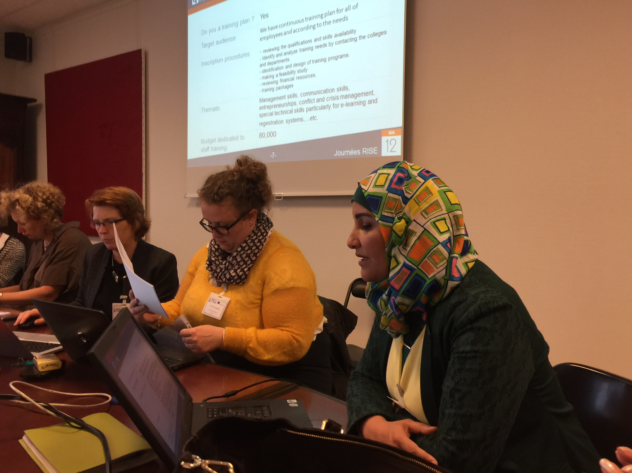

Wednesday 11th May
- Second day.
First session: Recruitment, presented by HR group of Rouen University.
- Main points are summarized in six question:
- How the staffing needs are evaluated?
- Who recruits?
- Is it a centralized management?
- What are the different types of personnel in your facility?
- How do you recruit?
- What are your tools?
- Recruitment divided into two parts:
- Recruitment of administrative (libraries personnel, Engineers, Administrative, Social and Health Technicians). (internal and External competitive exam).
- Recruitment of Teachers. (competitive exam at the national level).
- The Human Resource Department organizes the job campaign.
- Jobs vacancy identification Depends on: No. of sabbatical, non-payment, maternity leave and retirees.
- Staff recruitments procedures done by HR Departments:
- Publication of the posts.
- Composition of juries/commissions.
- File checking of applications.
- Notifying the members of the commission juries and the candidates to complete the process of recruitment.
- Publication of the results.
- Cases in which administrators is hired under contract basis:
- No appropriate candidate is found by the civil servant body for the desired jobs.
- Beneficiary of the obligation in the employment.
- Hiring for a specific period, for the cases when the process is too long or take much time..
- Temporary increase of activity.
- Cases in which teachers is hired under contract basis:
- Tenured professors' deficit.
- No appropriate candidate is found by the civil servant body for the desired jobs.
- Need for the intervention of a professional of the business sector.
- Important notes:
- Job description is on a national level.
- Each year the manager set with the employer to determine the his strength and the weakness points, and the objectives of the job.
- HR staff are trained to deal with problems they face, and how make interviews in professional manner.
- Sometimes they train people in different departments to become coordinators with HR specially when they need to spread some project or strategy.
- Student evaluation of teachers should be placed at HR Department.
- They do not hire who is older than 45 years old. (the retirement age is 65, and he should serve for 20 years at least)
- There are a specific proportion for people with special needs and disabilities in employments.

- Second session, HR policy and tools presented by HR group of Rouen University.
- Rouen HR showed that they did an assessment of jobs and workforce at the University.
- Classifying jobs in terms of expertise (in progress).
- Points of reference for the qualifications are:
  - reference document of national jobs.
  - annual interview feedback.

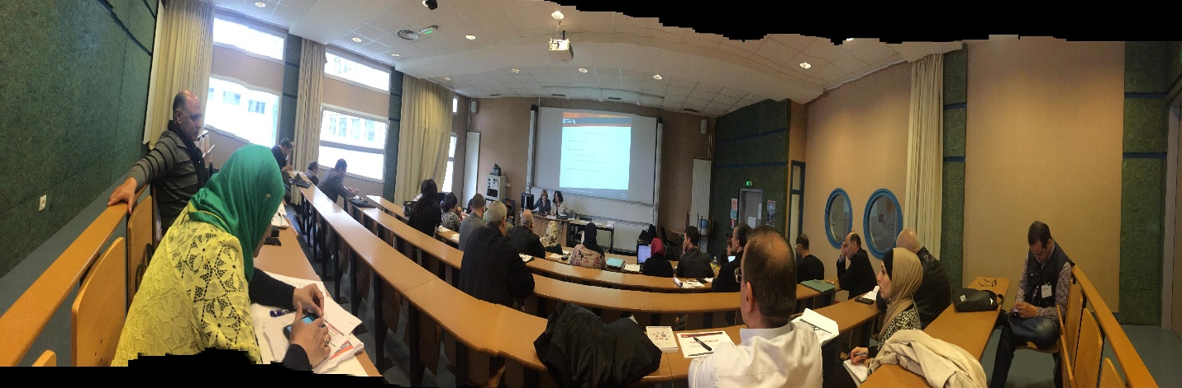

Thursday 12th May
- The third day,
First session, Training presented by HR Rouen group
- Main points are summarized in the following six subjects:
- Types of training.
- The financial organization of training.
- The partner involved in the training plan
- How they trained their staff (academic and administrative)
- The administrative organization of training
- Tools used in the training
- The training is targeting to the permanent and contract staff.
- The training needs are sent to HR department on April every year.
- Then all the training needs are discussed, reviewed and the new training plan is set.
- Usually the HR prepare the booklet of the training plan and published it on the University website.
- The employee who wants to attend a certain training course has to register for it (There is a deadline for registration for each course) so that the HR know the No. of trainees in each course.
- The employee can register more than a training course indicating his/ her priorities.
- Main topics of training; Computer sciences, Technologies of information and communication, Trainings for the teachers, FOCUS TICE (Technologies of Information and communication in workshop), Preparations in competitions, Management Software, Professional environment, Foreign languages, Hygiene, Security and Green Plan, Management trainings (supervision).
- Some training courses are mandatory such as Hygiene, Heath and Public safety.

- The training occurs either; internally, on- line, with external contractor and sometimes outside the country.
- Training of teaching staff usually done with coordination with the Ministry and Scientific Research.
- Training of teaching staff is in two levels; ICT and Pedagogy.

- Important questions and points are raised during the discussion:
- Is there a specific training hours for promotions? NO.
- If the employee registers more than one training course, can he/she attends them? Theoretically there is no specific numbers of training courses can be attended throw the year, but HR will ask the manager if this will not affect his work (when he will work??).
- Group training is usually a maximum of 12 employees.
- Sometimes there is an individual training.
- If the trainer is from the university and is payed for this, he should record a vacation deducted from his/ her annual vacations.
- If the trainer is one of the teaching staff, his teaching load may be reduced.
- If the training course is outside the plan, the trainee may ask to bear a part of the cost.

- Second session, HR working condition presented by HR group of Rouen University.
- Main points are summarized in six topics:
- Management of carrier: what kind of tools?
- Management of working time.
- Environment professional: which advantages?
- What are your tools?
- Management of your team: which tools?
- How pay your staff?

- The salary tables are established at the national level.
- Allowance system (Bonus) for teaching staff is different. With respect to teaching staff allowances are paid biannually, while for non-teaching staff are paid monthly.
- Carrier development for non-teaching staff depends on various plans:
- Promotion Table.
- Capacity List.
- Competition (internal, external).
- Professional Evaluation.
- Carrier development for teaching staff depends on various plans:
- Vacation for research or thematic conversions.
- Arrangement of services.
- Promotion table.
- List of capacity.
- Competition.
- Working Time / Non-Teaching Staff
- 37h/week
- 55 days annual vacations
- Working Time /Teaching staff:
- Teaching-Researcher Staff (192 hours teaching equivalent tutorial + activities of research).
- Teaching staff from high school and contractual (384 hours teaching equivalent tutorial)
- PhD contractual (Activities of research and for a few 64 hours of teaching equivalent tutorial).
- Professional Environment such as:
- Welcome new staff (one-day presentation, welcome book).
- Services dedicated to all staff (various financial reports, trips, events such as Christmas time, sports, health).
- Life quality of work (hygiene and security, evaluation of risks).
- Important questions and points are raised during the discussion:
- Flexible hours.
- Sick leaves are 90 days with full salary. Social security if the sick leave is more than 90 days.
- Maternity leave is 16 weeks. 3 days for husband.
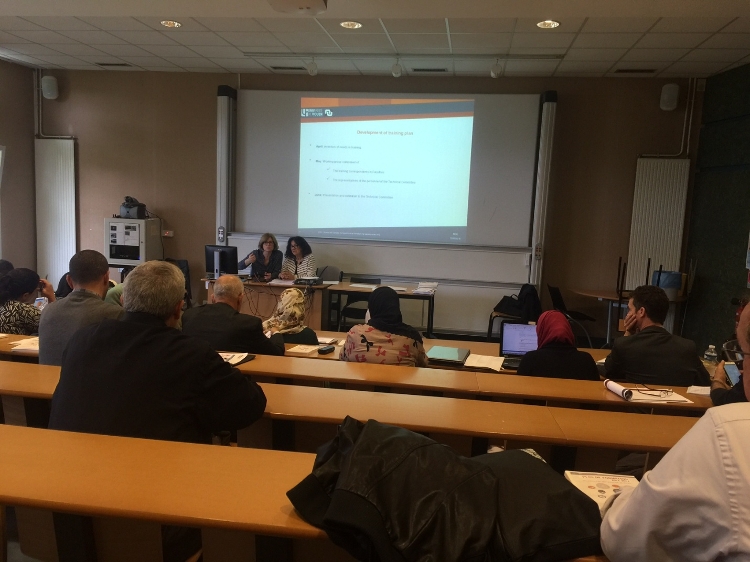

Friday 13th May
In the last day there were a review of all the topics that have been discussed in the last three days. A discussion was held about what the partners expect from the project. The expectations was:
- Raising the management capacity of HR employees.
- How to set training plans?
- How to prepare job descriptions and setting indicator of each job.
- How to build evaluation forms.
- Recruitment management.

Conclusions:
- The event was nicely organized.
- The presentations were related to the subject and informative.
- The visit was a very good opportunity to make warm discussions with the European delegates.
- The event was a good opportunity to have an idea about Rouen University experience in HRM.
- We should conduct several training courses for our university staff to involve them more in the RISE project.

Recommendations:
- Developing a clear action plan for all the next meetings.
- Diversification the methods of presenting the topics. (lecture, power point, discussions, training workshops).
- Focusing on how to raise the teaching and research capacity of the academic staff.
- Focusing on how to raise the management capacity of HR employees.
- Enhancing the exchange of experiences between partners.
- Designate a paragraph in each meeting to allow each partner to present his own experience in the field of the meeting. This aims at improving the partner's experience in the specified field.
- Focusing on how to determine the training needs for non-academic staff for improving their skills or to promote them.
- Knowing how to prepare forms of evaluation (for academic and non-academic).
- Knowing how making jobs more attractive for employees.

Signature

